Introduction to Data Science
Course Project
Report Document

Ammar Ahmed
20L-0961
BDS - 3B
Instructions: Read These Carefully Before Starting

- Due Date: Sunday 4th December 2022 – 11:59PM
- Submission will be taken on Google Classroom
- Submit only the following 2 files named like the following:
  - Code File (Jupyter Notebook): L210000_Code.ipynb
  - Report Document (This File): L210000_Report.pdf
- Project will not be evaluated if:
  - You submit python (.py) files
  - You submit multiple .ipynb files
  - You submit compressed (.rar or .zip) files
  - You submit any files other than the required PDF and IPYNB
- Upload data files directly to Google Colab - do not use Google Drive or GitHub linking method
- All source files needed to complete this project are uploaded with it on Google Classroom.
- Do not add the data file with your submission on Google Classroom.

Not following these instructions will lead to mark deduction.
Please try to use Microsoft Word instead of Google Docs to edit this document and to export it as a PDF file for final submission.

Happy Coding 😺
__________________________________________________________________________________

TA Emails
Section A, C - Muhammad Maarij l192347@lhr.nu.edu.pk
Section B, D - Hira Ijaz l192377@lhr.nu.edu.pk

For this project you will be applying machine learning models (both regression and classification) to the dataset which contains information about various individuals, their clothing, and its properties along with other atmospheric elements such as temperature, pressure humidity etc. The users also provided feedback on if they feel cold or not. The feedback (through AMV and PMV) which is based on the following mapping:
The following table shows the mapping of sensations:

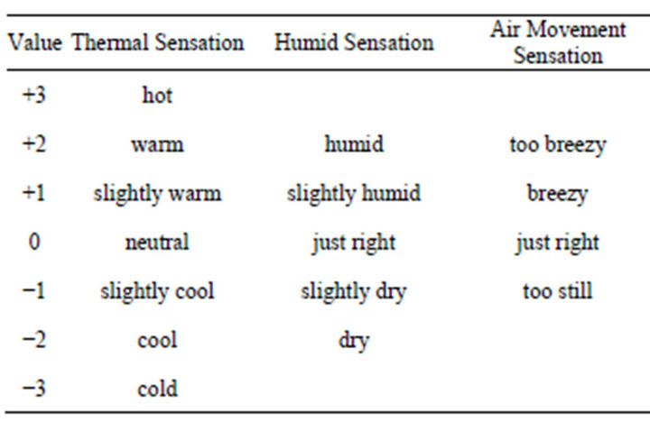

The dataset is given in an excel file named CollectedData.xlsx, see sheet 2 of excel file. The dimension names (column headers) are not mentioned in the given file. The table below describes the columns which will be of your interest.

Column number | Feature Name | Feature Description
3 | Age | Age
22 | Clo | Clothing insulation
19 | Met | Met Rate
26 | Dewpt | Dewpt
27 | PlaneRadTemp | plane radiant temperature
37 | Ta | Average air temperature
38 | Tmrt | Average mean radiant temperature
40 | Vel | Air Velocity
42 | AirTurb | Air Turbulance
43 | Pa | Vapor Pressure
44 | Rh | Humidity
74 | TaOutdoor | Outdoor Air Temperature
77 | RhOutdoor | Outdoor Humidity
8 | AMV | Classification response variable
49 | PMV | Regression response variable

Part A. Preprocessing
1. In this step, you are required to apply the preprocessing steps that you’ve covered in the course. Specifically, for each of the input dimension, fill in the following (add rows and complete the table for all input dimensions).

Dim Name | Data Type | Total Instances | Number of Nulls | Number of Outliers | Min. Value | Max Value | Mode | Mean | Median | Variance | STD
AGE | int | 9650 | 2915 | 1359 | 0.0 | 1996.0 | 24.0 | 34.431914 | 35.0 | 462556.55610368383 | 680.1151050400836
AMV | float64 | 12510 | 55 | 0 | -3.0 | 3.0 |  | 0.756536 | 0.0 | 1.2144300695666446 | 1.102011828233547
MET | float64 | 10678 | 1887 | 1731 | 0.1 | 4.5 | 0.0 | 1.032419 | 1.1 | 0.18393941634661357 | 0.42888158779156466
CLO | float64 | 11159 | 1406 | 373 | 0.15 | 2.13 |  | 13.621447 | 0.7517000000000001 | 0.04928355928831387 | 0.2219990074038933
DEWPT | float64 | 9014 | 3551 | 0 | -1.95 | 26.896 | 1.0 | 0.088585 | 14.1 | 34.84592820166446 | 5.903043977615655
PLANERADTEMP | float64 | 5544 | 7021 | 452 | -7.42 | 11.7 |  | 23.051694 | 0.2 | 1.084022292053154 | 1.041163912193058
TA | float64  float64 | 12545 | 20 | 539 | 15.96 | 31.0 | 0.77 | 23.341065 | 23.136666666666667 | 2.053443494259767 | 1.4329841221240964
TMRT | float64 | 8864 | 3701 | 343 | 16.61 | 37.445 |  | 0.103061 | 23.359219155321334 | 2.2574746335420053 | 1.5024894786793035
VEL | float64 | 8865 | 3700 | 309 | 0.0 | 1.88 | 17.4 | 18.242436 | 0.1 | 0.00624789908810920 | 0.07904365305392462
AIRTURB | float64 | 6965 | 5600 | 2 | 0.0 | 102.45 |  | 1.436215 | 0.5 | 627.0571287191916 | 25.04110877575495
PA | float64 | 7910 | 4655 | 1352 | 0.0 | 27.7 | 0.3 | 42.528507 | 1.5506666666666669 | 66.5225623700926 | 8.156136485499283
RH | float64 | 12530 | 35 | 0 | 7.4 | 79.3 |  | 17.175087 | 43.27681475840521 | 226.84801722776646 | 15.061474603363592
PMV | float64 | 11869 | 696 | 259 | -4.17 | 2.5 | 23.2 | 61.098939 | -0.03 | 0.28947130007583083 | 0.5380253712194536
TAOUTDOOR | float64 | 11197 | 1368 | 124 | -24.9 | 32.35 |  | 0.100584 | 18.2 | 113.75106669840022 | 10.66541451132586
RHOUTDOOR | float64 | 12546 | 19 | 1349 | 0.0 | 100.35 | 22.5 | -0.088351 | 68.79579929928357 | 610.3055825825974 | 24.704363634439105

2. For each of the input dimension, plot histogram and comment the type of distribution the dimension exhibits. Further, visualize each dimension using a Box Plot. Specifically, for each of the input dimension, you’re required to fill the following table (duplicate it for each of the 15 dimensions).
Age
Histogram | Box Plot
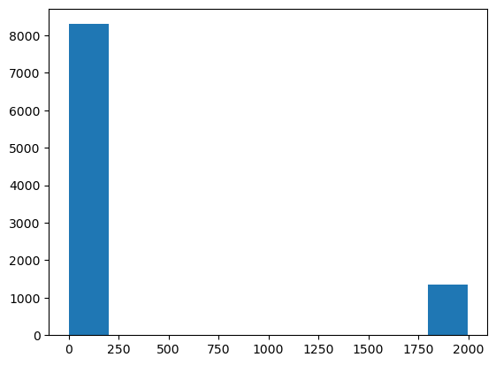 | 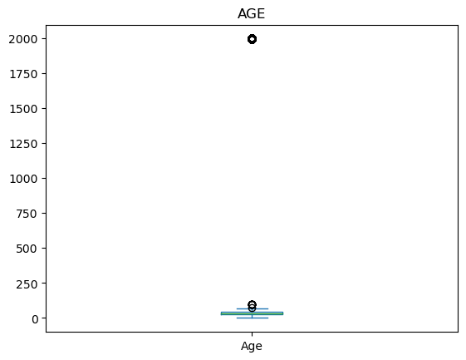
Comments:more outliers | Comments: more outliers

AMV
Histogram | Box Plot
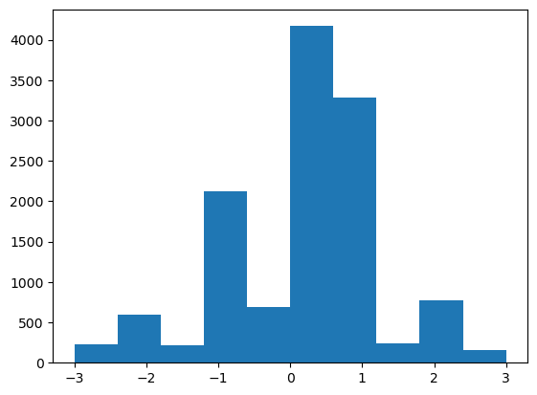 | 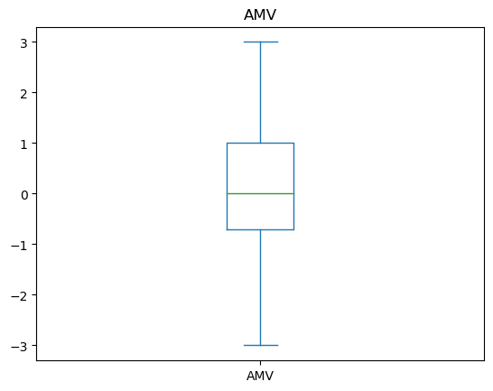
Comments: less outliers | Comments:less outliers

Met
Histogram | Box Plot
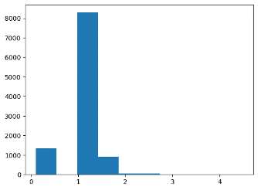 | 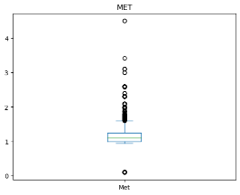
Comments: more outliers | Comments: more outliers

Clo
Histogram | Box Plot
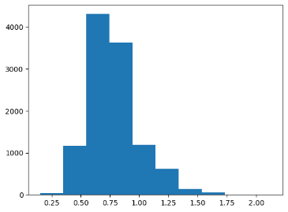 | 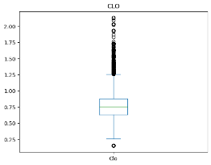
Comments: more outliers | Comments: more outliers

Dewpt
Histogram | Box Plot
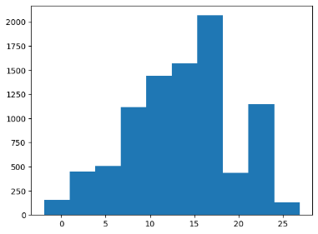 | 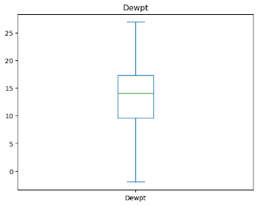
Comments: more outliers | Comments:less outliers

PlaneRadTemp
Histogram | Box Plot
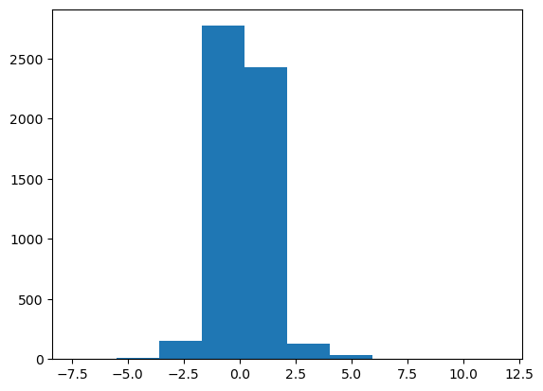 | 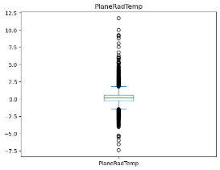
Comments:less outliers | Comments: more outliers

Ta
Histogram | Box Plot
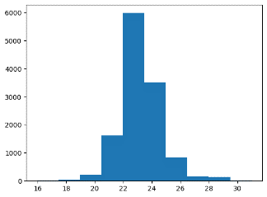 | 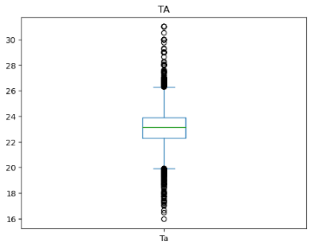
Comments: more outliers | Comments: more outliers

Tmrt
Histogram | Box Plot
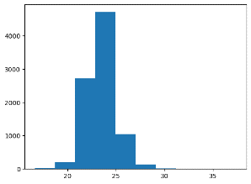 | 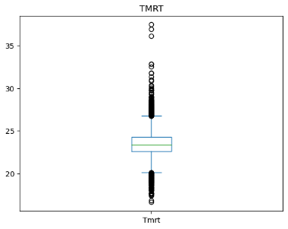
Comments:less outliers | Comments: more outliers

Vel
Histogram | Box Plot
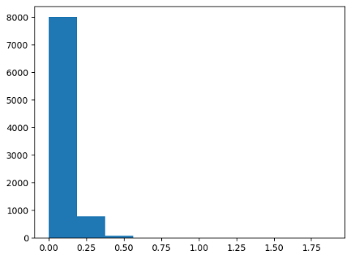 | 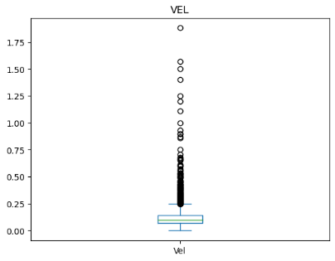
Comments:less outliers | Comments: more outliers

AirTurb
Histogram | Box Plot
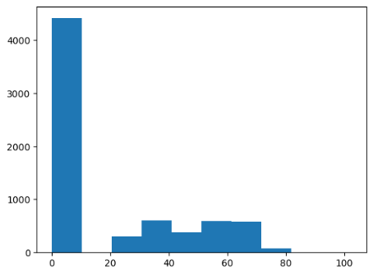 | 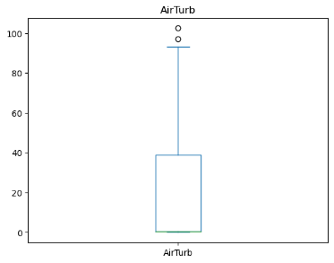
Comments:less outliers | Comments: more outliers

Pa
Histogram | Box Plot
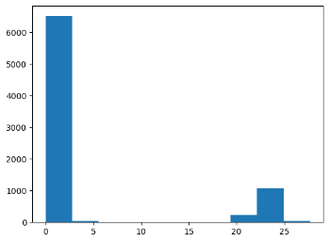 | 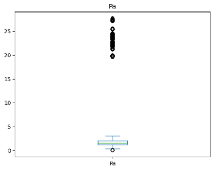
Comments: more outliers | Comments:less outlers
Rh
Histogram | Box Plot
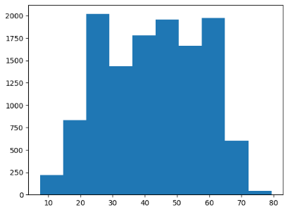 | 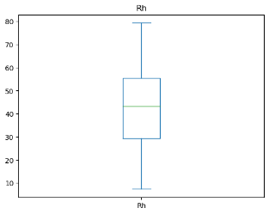
Comments: more outliers | Comments: more outliers

PMV
Histogram | Box Plot
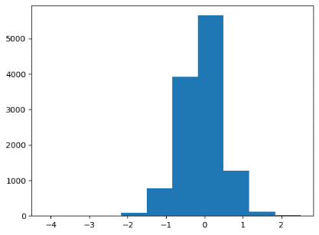 | 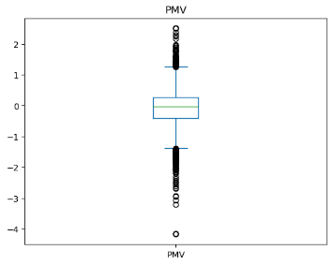
Comments:less outlers | Comments: more outliers

TaOutdoor
Histogram | Box Plot
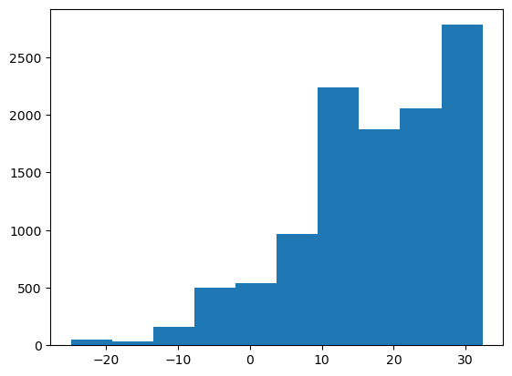 | 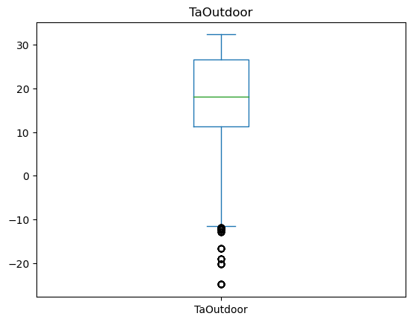
Comments: more outliers | Comments: more outliers

RhOutdoor
Histogram | Box Plot
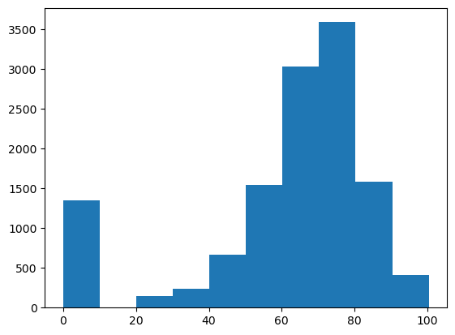 | 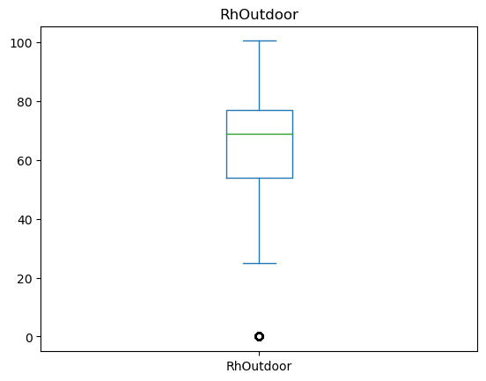
Comments: | Comments:

3. Find the missing values in each of the dimension (do this for both input and output dimensions), and fill these using an “appropriate” methodology that we’ve discussed in the class. You may also choose to drop a certain sample based on your analysis. Mention your approach and its justification.

Dim Name | Number of Missing Values | Filled using OR Dropped | Reason for selecting a certain approach
AGE | 2915 | Taking Mean of column | Easy and intuitive
AMV | 55 | Taking Mean of column | Easy and intuitive
MET | 1887 | Taking Mean of column | Easy and intuitive
CLO | 1406 | Taking Mean of column | Easy and intuitive
DEWPT | 3551 | Taking Mean of column | Easy and intuitive
PLANERADTEMP | 7021 | Taking Mean of column | Easy and intuitive
TA | 20 | Taking Mean of column | Easy and intuitive
TMRT | 3701 | Taking Mean of column | Easy and intuitive
VEL | 3700 | Taking Mean of column | Easy and intuitive
AIRTURB | 5600 | Taking Mean of column | Easy and intuitive
PA | 4655 | Taking Mean of column | Easy and intuitive
RH | 35 | Taking Mean of column | Easy and intuitive
PMV | 696 | Taking Mean of column | Easy and intuitive
TAOUTDOOR | 1368 | Taking Mean of column | Easy and intuitive
RHOUTDOOR | 19 | Taking Mean of column | Easy and intuitive

4. For each of the dimension, find out the outliers (noisy data) and handle these appropriately.

Dim Name | Number of Outliers | Smooth using/ Dropped | Reason for selecting a certain approach
AGE | 1359 | Smoothing using iqr | Variability where mode lies
AMV | 0 | Smoothing using iqr | Variability where mode lies
MET | 1731 | Smoothing using iqr | Variability where mode lies
CLO | 373 | Smoothing using iqr | Variability where mode lies
DEWPT | 0 | Smoothing using iqr | Variability where mode lies
PLANERADTEMP | 452 | Smoothing using iqr | Variability where mode lies
TA | 539 | Smoothing using iqr | Variability where mode lies
TMRT | 343 | Smoothing using iqr | Variability where mode lies
VEL | 309 | Smoothing using iqr | Variability where mode lies
AIRTURB | 2 | Smoothing using iqr | Variability where mode lies
PA | 1352 | Smoothing using iqr | Variability where mode lies
RH | 0 | Smoothing using iqr | Variability where mode lies
PMV | 259 | Smoothing using iqr | Variability where mode lies
TAOUTDOOR | 124 | Smoothing using iqr | Variability where mode lies
RHOUTDOOR | 1349 | Smoothing using iqr | Variability where mode lies

5. Using the variance that you’ve calculated above, for each dimension, comment whether you’ll select the input dimension or no. (don’t drop a dimension at this point)
Dim Name | Variance | Apply filter or no, reason
AGE | 462556.55610368383 | None (high variance)
AMV | 1.2144300695666446 | Filter
MET | 0.18393941634661357 | Filter
CLO | 0.04928355928831387 | Filter
DEWPT | 34.84592820166446 | Filter
PLANERADTEMP | 1.084022292053154 | Filter
TA | 2.053443494259767 | Filter
TMRT | 2.2574746335420053 | Filter
VEL | 0.00624789908810920 | Filter
AIRTURB | 627.0571287191916 | Filter
PA | 66.5225623700926 | None (high variance)
RH | 226.84801722776646 | None (high variance)
PMV | 0.28947130007583083 | Filter
TAOUTDOOR | 113.75106669840022 | Filter
RHOUTDOOR | 610.3055825825974 | Filter

6A. Create a correlation matrix (Heat Map) for all the dimensions (input and output).

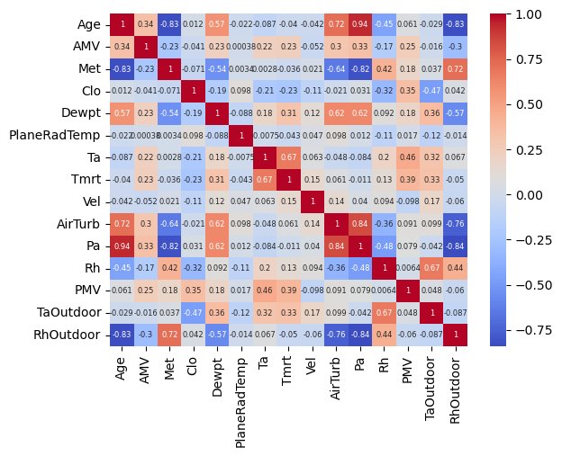
6B. Using the above correlation matrix, comment what are the most informative dimensions, and which are the least. Note that, be careful since we have two response variables in the dataset (i.e., PMV and AMV regression and classification respectively)

PMV:
Most Informative: Age, Vel, AirTurb, Pa, Rh, TaOutdoor, RhOutdoor
Least informative: AMV, Met, Clo, Dewpt, PlaneRadTemp, Ta, Tmrt
AMV:
Most Informative:Age, Met, Clo, Vel, AirTurb, Pa, Rh, TaOutdoor, RhOutdoor
Least Informative: Dewpt, PlaneRadTemp, Ta, Tmrt, PMV
7. Apply entropy followed by information gain on the selected columns. Specify your selection criteria.
Dim name | Entropy | Info Gain | Reason
AGE | 4.496 | 0.248 | Info gain>than threshold
AMV | 3.506 | _ | Info gain>than threshold
MET | 5.197 | 0.338 | Info gain>than threshold
CLO | 7.425 | 0.392 | Info gain>than threshold
DEWPT | 7.855 | 0.79 | Info gain>than threshold
PLANERADTEMP | 5.169 | 0.466 | Info gain>than threshold
TA | 8.286 | 0.623 | Info gain>than threshold
TMRT | 8.203 | 0.773 | Info gain>than threshold
VEL | 5.58 | 0.337 | Info gain>than threshold
AIRTURB | 6.402 | 0.763 | Info gain>than threshold
PA | 7.352 | 0.98 | Info gain>than threshold
RH | 10.879 | 1.186 | Info gain>than threshold
PMV | 7.566 | 0.309 | Info gain>than threshold
TAOUTDOOR | 7.652 | 0.434 | Info gain>than threshold
RHOUTDOOR | 7.204 | 0.389 | Info gain>than threshold

Part B. Applying Algorithms
1. For this part, split the data randomly into 80/20 percent. Where 80% represents the training data. Also normalize the dataset as you see fit.
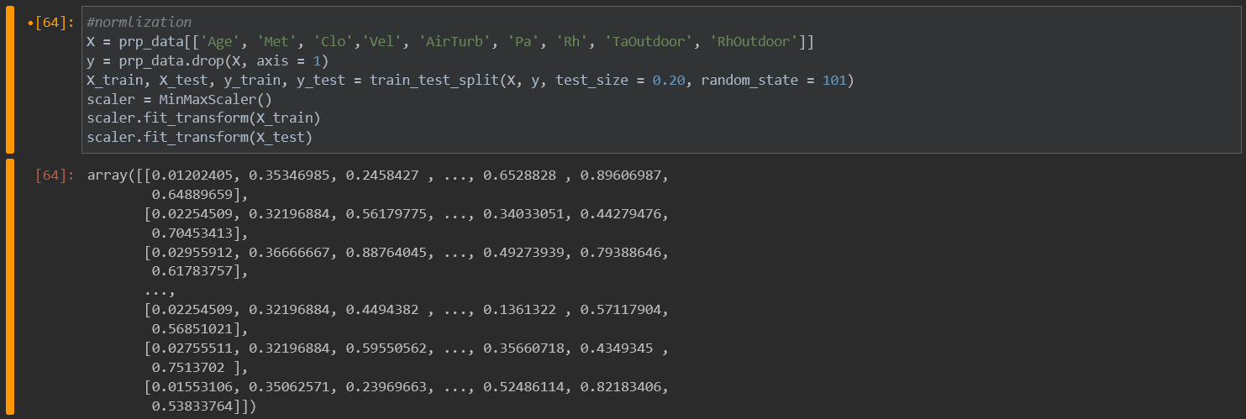
2A. Apply forward selection, considering PMV as response variable and Multilinear regression as machine learning model. Create a table, that mentions dimensions, and performance achieved. Which is the optimal feature set, and why.
Feature Vector | Performance achieved
Age,Pa,Rh,TaOutdoor,Rhoutdoor | 100%

2B. Apply backward selection, considering PMV as response variable and Multilinear regression as machine learning model. Create a table, that mentions dimensions, and performance achieved. Which is the optimal feature set, and why.
Feature Vector | Performance achieved
Age,Pa,Rh,TaOutdoor,Rhoutdoor | 100%

3A. Apply forward selection, considering AMV as response variable and Logistic regression as machine learning model. Create a table, that mentions dimensions, and performance achieved. Which is the optimal feature set, and why.
Feature Vector | Performance achieved
Age,vel,Rh,TaOutdoor,Rhoutdoor | 50.26%

3B. Apply backward selection, considering AMV as response variable and Logistic regression as machine learning model. Create a table, that mentions dimensions, and performance achieved. Which is the optimal feature set, and why.
Feature Vector | Performance achieved
Met,AirTurb,Rh,TaOutdoor,RhOutdoor | 50.02%

4. Using the optimal feature vector that you’ve figured out from your analysis above, apply 3-fold cross validation for both regression and classification problems (PMV and AMV respectively). Write down the optimal parameters values for each of the model. Further, plot confusion matrix for the classification part.

